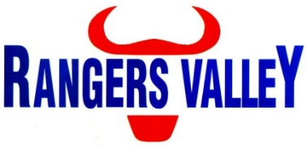

Feedmill Operator

Location: Rangers Valley Feedlot, NSW
Employment Type: Full-Time

Rangers Valley is a leader in premium beef production, renowned for quality, innovation, and operational excellence. We are currently seeking a dedicated and safety-focused Feedmill Operator to join our high-performing team.
This role is suited to an individual who thrives in a hands-on environment and takes pride in maintaining the highest standards in feed preparation and machinery operation.

Key Responsibilities:
- Operate all feedmill equipment in accordance with Safe Work Procedures and OH&S policies
- Manage feed commodities to ensure timely delivery and preserve product quality
- Monitor and maintain feed consistency, flake weights, and grain moisture as per nutritional targets
- Complete routine maintenance and assist with equipment repairs
- Maintain accurate daily records relating to feed production and resource usage
- Ensure all feedmill and grain receival areas are clean, safe, and well-presented
- Support ongoing improvements in feed preparation and delivery processes

About You:
- Prior experience in feedmill or agricultural operations is highly regarded, but not essential.
- Mechanically minded with the ability to carry out basic maintenance and troubleshooting
- Strong attention to detail with sound record-keeping and time management skills
- A proactive team player with a strong commitment to safety and quality standards

What We Offer:
- The opportunity to work with a respected and progressive industry leader
- Above award wages
- A supportive and collaborative team environment
- Ongoing training and development opportunities

Please forward applications to careers@rangersvalley.com.au

For further information please contact the Manager – HR, IT & Compliance on 02 67344000.

