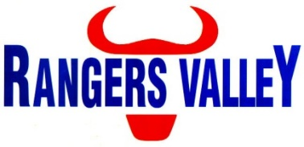

Apprentice Mobile Plant Mechanic
Are you looking to work in the agricultural sector for one of Australia’s leading branded beef companies?
Rangers Valley specialises in the production of high quality long fed beef and is seeking a responsible and organised individual to join our team as an Apprentice Mobile Plant Mechanic.
This is a unique opportunity to be part of a premium beef business with a strong continuing growth strategy.
Based at Rangers Valley’s feedlot located 30km north of Glen Innes and reporting to the Maintenance Manager you will be interested in undertaking a career in plant maintenance and in completing a Mobile Plant Mechanic apprenticeship under the guidance of industry specialists , this position will be an integral part within the Rangers Valley team.
Some of the activities and duties you will learn
- Carry out adhoc and routine maintenance and repairs to mobile and static plant, ensuring all equipment is operational and safe for use,
- Fault finding and diagnosis
- Complying with safe work procedures and practices,
- Carry out plant inspection check lists,
- Maintain a neat and tidy workshop and work area,
- Participate in safety meetings as required.
- Initiate and communicate improvement ideas that improve efficiency, reduce waste and costs.

What we seek in our apprentices
- Minimum Year 10 completion.
- Drivers licence.
- Technical aptitude and a mechanical interest.
- Ability to work in teams.
- Ability to maintain an energetic, self motivated and enthusiastic work ethic.
- Strong safety and environmental awareness.
- Strong communication and interpersonal skills.
- Experience or knowledge of mechanical or machinery would be advantageous but not required.

What we offer:
- Stable employment
- Opportunity to work in a highly successful and experienced team.
- Genuine career development opportunities.
- Support undertaking TAFE studies in Certificate III Mobile Plant Technology

For further enquiries regarding the position please contact Aaron Childs on 02 6734 4000 or email childsa@rangersvalley.com.au.
To apply please forward applications to childsa@rangersvalley.com.au. Applications should include a cover letter with why you feel you would be suited to a career with Rangers Valley and your resume, including detail of any work experience or current work you have. As well as any other information you think will help with your application.

